22.34:
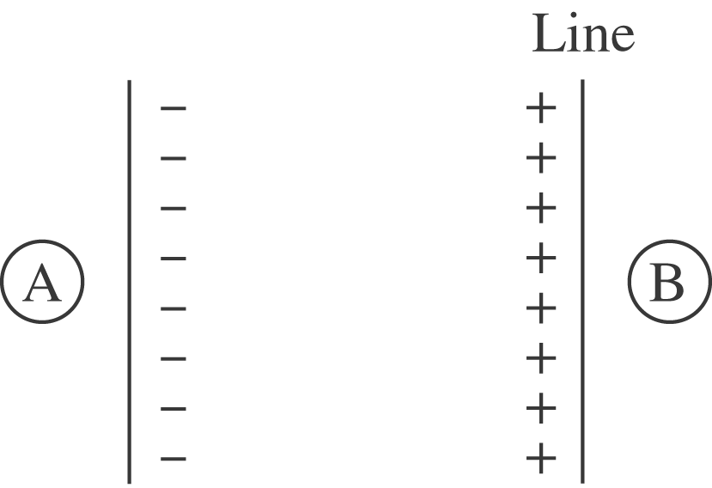

The particle feels no force where the net electric field is zero. The fields can cancel only in regions A and B.
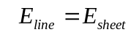
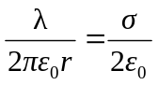
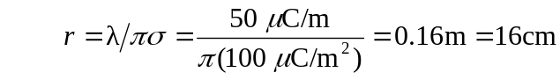
The fields cancel 16 cm from the line in regions A and B.

